Requirement Analysis

* Server environment
* **Machine:** A physical machine (MacBook Pro)
* **Operating System:** Mac OS
* **Web application infrastructure:** Apache + PHP + MySQL by XAMPP
* **Websocket:** Rachet websocket server on port 8080
* **Domain Name:** [bubblechat.hopto.org](http://bubblebeetv.sytes.net) ( 30 days confirmation from no.ip.com )
* **SSL ( HTTPS ) Setup:**

1. Register a FQDN (Fully Qualified Domain Name) for your server

In order the ISP provide us a dynamic IP address, we need to applied a 30 days confirmation DDNS from no.ip.com.

1. Create a private key pair and certificate signing request

openssl genrsa -out bubblechat.hopto.org.key 2048

openssl req -new -key bubblechat.hopto.org.key -out bubblechat.hopto.org.csr

Enter a country code: HK

Enter a province name: Hong Kong

Enter your city name: New Territories

Enter your organization name: BubbleChat

Enter your organizational unit: BubbleChatDeveloper

The common name: bubblechat.hopto.org

Enter in a general contact e-mail address: [bubblechatcorp@gmail.com](mailto:bubblechatcorp@gmail.com)

You can leave the challenge password blank:

You can leave the optional company name blank:

1. Submitting the Certificate Signing Request to a CA



We go to SSL For Free, then submit our CSR and did the HTTP(S)-based DCV to verify we are the host of our domain name.

We download the file from SSL For Free, then put the file follow this path: [bubblechat.hopto.org/.well-known/pki-validation/73A6ECBA797847F87E18B9B4F29DA576.txt](http://bubblebeetv.sytes.net/.well-known/pki-validation/73A6ECBA797847F87E18B9B4F29DA576.txt)

1. Installing Certificate on XAMPP Server from CA

Once we verified, they send us a zipped file called sslforfree.zip, which contain

Intermediate Certificate --> ca_bunble.crt

Certificate File --> certificate.crt

Our private key --> private.key

After it, we install it to our xampp/etc/ssl file.

1. Configure Apache on XAMPP Server for SSL Connection

First, we open the xampp/etc/httpd.conf file and uncomment line

#Include conf/extra/httpd-ssl.conf

Which can allow us to use SSL and modify the setting.

Then, open the file httpd-ssl.conf on the same path, and insert 3 line

SSLCertificateFile "/ssl/server.crt"

SSLCertificateKeyFile "/ssl/server.key"

SSLCACertificateFile "/ssl/server.ca-bundle"

1. Configure HTTP to HTTPS

We add a file called .htcaccess to our web server root, then insert below code to ensure whenever user go to http, it will redirect them to https.

RewriteEngine On

RewriteCond %{HTTP_HOST} bubblechat\.hopto\.org [NC]

RewriteCond %{SERVER_PORT} 80

RewriteRule ^(.*)$ https://bubblechat.hopto.org /$1 [R,L]

* Coding environment
* **IDE / Text Editor:** Atom

It provide a package called Teletype which allow us to share the server host’s workspace with team members and collaborate on code in real time.

* Client environment

Our website supports every modern/common browser.

System Design

* System Structure

There are three main parts in the system, the frontend design ( e.g. CSS, Bootstrap, Font, etc.), the backend design for the user information handling (Storing user information in database, login verification, email verification, modifying user information ) and the backend design and WebSocket about the chat function. In the aspect of colour, a white and black colour combination are good for the user to read the text of our application. In the aspect of user friendly, the picture and the icon size are big enough for the user to see and no vague, all the button are having size big enough calculate by the Fitts's law to have a perfect button size which suitable for the mouse pointer of the user, all application design are aim to provide the best experience for the application user.

Frontend design:

We mainly use bootstrap to modify the appearance of our application, in the login and the registration form, we use the modal class of the bootstrap, which is a popup form for user to input their information, also the form inside we also use different class of the bootstrap like the form control class and to verify the correct information by using the invalid-feedback class, besides the form, the nav bar is also use the bootstrap for designing. About the icon of our application, we use font awesome to create some fancy icon for our application.

Backend design (User information):

First, the index.php is used to store all the login form and the registration form for the user to use, once the form receive the information input by the user, it will post the form result to different PHP file for further verification which are login.php and signup.php in the backend file. After the verification those php page will return the result back to the index for the next step like whether the login is success or not, or the registration is success or not. Base on the return result, the server will do different action such as send verification email or redirect the browser to another page.

Another important aspect of the backend is to deal with the information provided by the user and store it in the database, a detailed database design will list in the section below, db_connect.php is the php file that can let out application connect to the database, it store the database name and the password inside, every time the application needs to connect to the database the application will run the “require” to extract the code in db_connect.php in order to connect to the database. To modify the data in the database we will use the SQL code and the it can change the modify the database content, such as insert new record, update the database record or delete the database record, we use prepare statement then bind the parameter to the SQL statement to enforcement the safety level of the application, this method can avoid some attack like SQL injection or cross site scripting(XSS).

For the email verification of the application, we will use the mail.php in the backend file, it is a file that include the information about the smtp server and the script that can let the application send a email to a specific email address, when then application need to use the mail function, it will use the “require_once” for extract the code in the mail.php and run the code about sending email to the user.

Backend design (Chatroom function):

The chat function is the most important function in the application, which needs real time client side to server-side communication. In the chatroom.php and the WebSocket file, it includes script which can set up a stable connect between the client and the server. If one client send a message, it will first send to the server and then the server will transfer the message to all other user, the chatroom.php indicate how the message send to the server and the server.php in the WebSocket file will verify the resource of the message and show it in the chatroom webpage for all other users.

* Network design diagram

* Webpage structure diagram

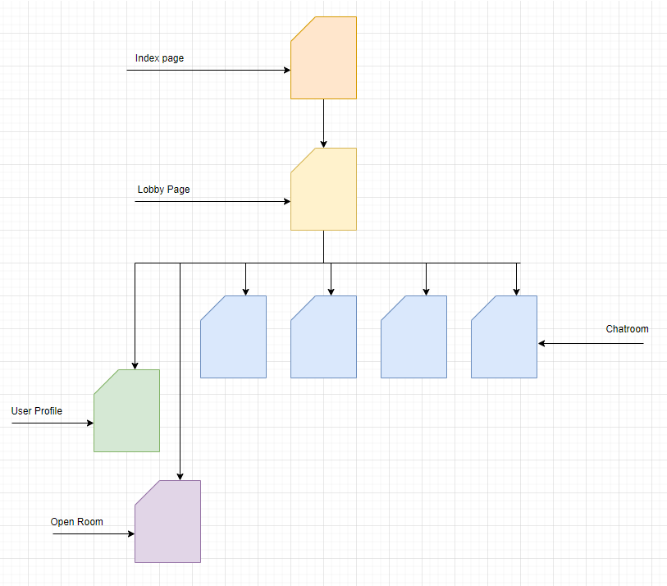

Database Design

Our website is a membership website. People around the world can visit our homepage only. Therefore, they need to sign up for more function, like profile editing, chatroom function.

There are two tables in our database which are User, Chatroom to implement the BubbleChat Online Chat Application. Chatroom table store all the information about the chatroom which is the room id of the room and the room name, the User table stores all information about a user which includes the nickname, email address etc.

* **User**



User table store all the information provided by the user when the register an account, which includes Username, Nickname, Password in the hashed form, Password Salt, Age, Email address, Gender, Location, Profile_image, Email token and whether the user activate their account or not.

* Chatroom



Chatroom table only includes three column which are RoomID, RoomName and the Owner, RoomID is a unique identifier to specify all chatroom, RoomName is the name of the chatroom and the Owner specify which user create the chatroom.

System Flow

**Account Registeration Flow**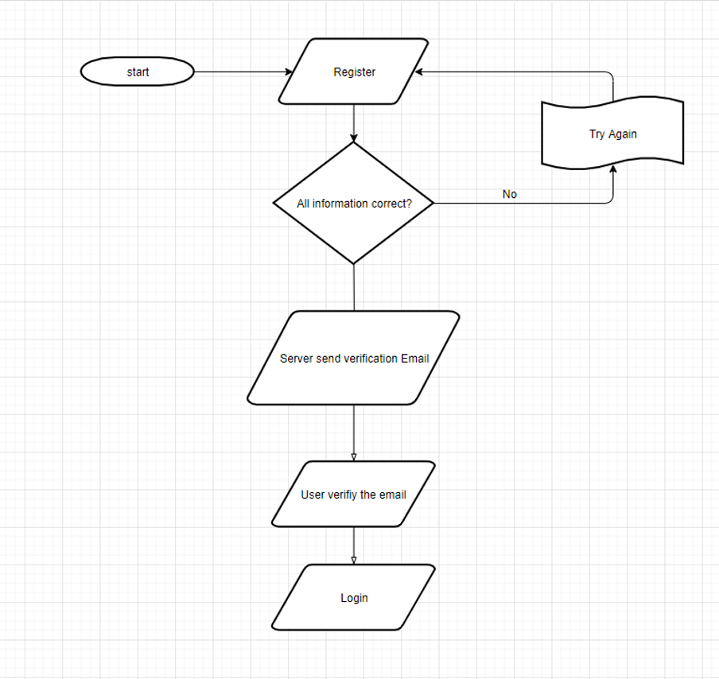

**Login Flow**



**Forget Password flow**

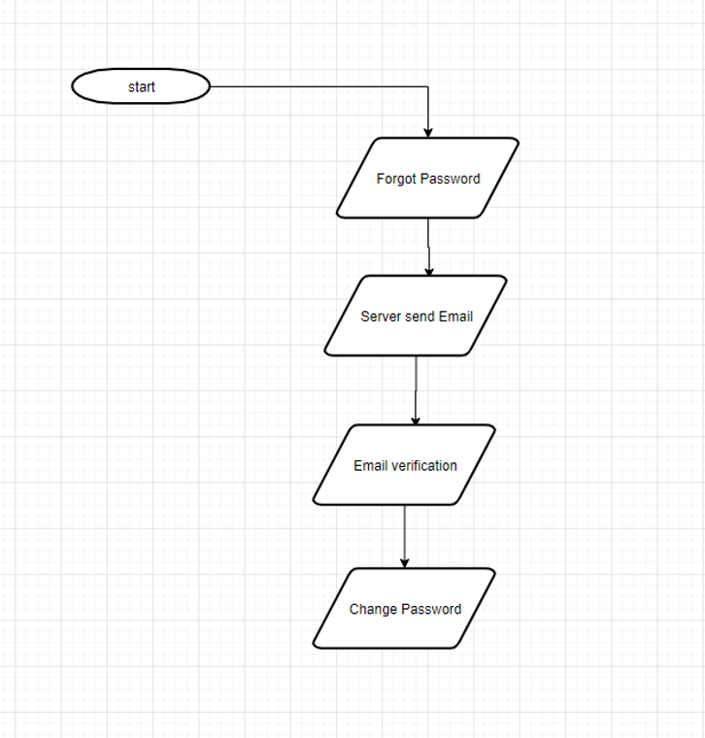

Techniques adopted during implementation

* Framework

**Bootstrap**

We use the bootstrap CSS framework for user interface. We used the responsive grid system to have a better layout.

* Libraries

**Font Awesome**

It is the libraries for designing the icon. We used it to make up our application’s icon.

**JQuery**

More convenience library for Javascripts.

**Ajax**

Ajax stands for Asynchronous JavaScript and XML. AJAX allows web pages to be updated asynchronously by exchanging data with a web server behind the scenes. We used Ajax to send submit the form asynchronously without refresh the browser.

**Ratchet**

Ratchet is a loosely coupled PHP library providing developers with tools to create real time, bi-directional applications between clients and servers over WebSocket’s. We used the ratchet for message communication in the chatroom.

* Websites

**SSL For Free** ( <https://www.sslforfree.com> )

We visit SSL For Free then enter our domain name and follow the procedure to gain the SSL certification.

**Qualys SSL Labs** ( <https://www.ssllabs.com/ssltest> )

Security Report of our website certificate information and security level.

Function of the application

* User Registration

User provides their information to register a account in the chat application, such as the full name and the nickname show in the application, email and the password.

* Email verification

After a user account is created, the system will send a email to the email address which the user entered, user must go the email account the provide to verify the account in order to activate the account.

* Login with the captcha and with the salted password

After the user activate the account via the email sent by the server, user can login the application, while the user is login the system, the need to answer a captcha question to make sure you are not a robot. All password user input will store in the database as a salted hash form also with the salt.

* Forgot Password and password change

When user forgot their password, they can request a email same form the email address they Input when the register the account to change their password, also the user can change their password freely after they login.

* User profile

User can modify their information such as the personal image or the password in this page.

* Chat function

The chat function is the major function in our application, the user can join a chat room and type in the message they want to say and every one can watch the message, not just a simply text message but also some image like the emoji, it is a real time chat function over websocket such that there will not be a huge delay in the message transfer.

Security Measurements

* SSL ( Secure Socket Layer )

We use SSL to protect all communication between the client side and the server side, SSL is a protocol that can encrypt the data packet to prevent anyone to steal those packets during the transmission, which enforce the confidentiality of the application. Thus, the website will be using the https instead of http to run the application.

* Password Hashing with salt

As we think that only store the user password in a plaintext form to the database are really insecure such that we decide to store the password in the database in a hashed form, but it still can solve the brute force problem so that we add a random salt to concatenate with the password which makes the combination of the hash being complicated and unexpected and lets the attacker need to test all possible combinations of salt and password to brute force the password out, but as our salt is 8 character, it is nearly impossible to test out all possible combination in a short period. After the password is set by the user, the system will generate a 8 character salt and store both the salted hash by Bcrypt and the salt into the database, every time when the user login to the application, the system will extract the salt and calculate the salted hash again and compare to the database record to let the user login.

* Email Verification Token

Same as the password, the email activation link basic is using a URL with the get method to extract the information, user can brute force the application via this URL, so we generate a token in every email send by the server, which make the URL needs to use with the token. This setting slightly increases the possible combination of the email address and the token and prevent the attacker to brute force the system.

* Prepare SQL Statement

Another threat of the application is the database of the application which contains all user information. The attacker can change the script to extract the data in the application database which cause a data leakage. In order to prevent this kind of situation, we use the SQL prepare statement to make sure any illegal character will not affect the SQL statement of the application and bind all data type of the parameter given to minimise the risk that such kind of attack like SQL injection or XSS(Cross Site Scripting) attack happen in the application.

* Content security policy

Content-security-policy is a policy that restricts the websites script object style front resources. It mainly used a white list of restrictions. It can even limit the “eval” appears. In general, after we set up the content-security-policy, only the resource which is inside the white list can be accessed the data.

Add

Header set Content-Security-Policy: "default-src 'none'; script-src 'self' 'unsafe-inline' https://www.google.com https://www.gstatic.com https://kit.fontawesome.com https://ajax.googleapis.com https://vjs.zencdn.net https://cdn.jsdelivr.net https://code.jquery.com https://stackpath.bootstrapcdn.com; object-src 'self'; style-src 'self' 'unsafe-inline' https://stackpath.bootstrapcdn.com https://vjs.zencdn.net https://kit-free.fontawesome.com; img-src 'self' data:; media-src 'self'; frame-src https://www.google.com; frame-ancestors 'none'; font-src 'self' https://kit-free.fontawesome.com; connect-src 'self'; block-all-mixed-content"

in .htaccess file

* X-Frame-Options

This option is used for preventing clickjacking. X-Frame-Option is used for setting the website and check which website can access through the iframe frame method. We set this option to Same Origin. SameOrigin is allowing the websites from the same resources access by iframe. We can prevent other website use iframe to access our website by using this option.

Add Header set X-Content-Type-Options nosniff in .htaccess file

* X-content-Type-Options

The reason we use this option is to prevent the browser mislead the link. In this web page, we set this option for preventing the content-type is being tampered.

If the style content-type is not text or CSS, it will be denied. As well as it will reject the non-JavaScript MIME type.

Add Header set X-Content-Type-Options nosniff in .htaccess file

* Strict-Transport Security

It forced the users to use HTTPS to connect our websites for preventing the Man-In-The-Middle attack. This security enhanced the https defensive protection, after setting up, users are being re-directed to the https connection.

Add “Strict-Transport-Secuirty; max-age=16070400; includeSubDomains” in httpd.conf file

* Secure, HTTP Only Cookies

Add

php_value session.cookie_httponly 1

php_value session.cookie_secure 1

in .htaccess file

Testing strategies

There are six major aspect that we need to test in our code of our application, which are the Hyperlink, Forms, Cookies and Session, WebSocket, HTML and CSS.

Hyperlink:

We need to test all the hyperlink to make sure all hyperlink is completely work and there are no any broken links, which includes the outgoing links and the internal links.

Forms:

We need to check the form is working as expected, all error message should be shown when the information is missing or wrong, also the default value should be being populated, third, the form should submit to the correct page and the format of the form should be readable.

Cookies and Session:

We need to check the cookies and the session should be create and destroy normally under the request of the application or after the time expired.

WebSocket:

We need to check the connection between client side and the server work normally, the data can be successfully transfer through the user and the application.

HTML:

We need to check there is no any syntax error in the HTML code which can cause the exception.

CSS:

We need to check all the colour pattern is readable for the user and user-friendly.

After checking these aspects, the website should be workable, but we also need to check the database to see the whether the record in the database can be insert, update or delete successfully. Then, we should take care of the user aspect and see it the whole application is user-friendly such as the font size and the font family is readable. Eventually, we should care about the security about the application and see the security setting of the application is safe, like the SSL setting, prepare statement and all other codes related to the security of the application.

Import in the real deployment

We register a domain name <https://bubblechat.hopto.org> which make this application not just can deploy in a local host but also in another physical device rather than the server device itself which means that any devices in different network can surf to this web when the web server is opening and enjoy the chat function.

* Mobility support

As this application is web-based, Smartphone user can also surf to this webpage by the browser of their phone, but due to the bootstrap setting, the layout of the mobile version will be different compare with the PC version.

* User manual

Sign up an account in the top right corner of the application, then input all information require, then go to the email for the email activation, then login the application in the top right corner of the application, after login to the application, you can choose a chatroom you like to join by simply press the name or the icon of the chatroom, or you can open a new chatroom by click the open room button and input the room name. Besides, you can also click the user image in the corner to the user profile page to change the personal information. Eventually, after you finish the use the chat function, you can logout the account by click the logout button in the corner.

* Install Guide

Put all the code in the web server root file and fetch all SQL file to the database, then use

Command Port / Terminal to open the htdocs/webSocket/server path, then run the server.php by this command “php server.php”.

Final Results Achieved

* Homepage

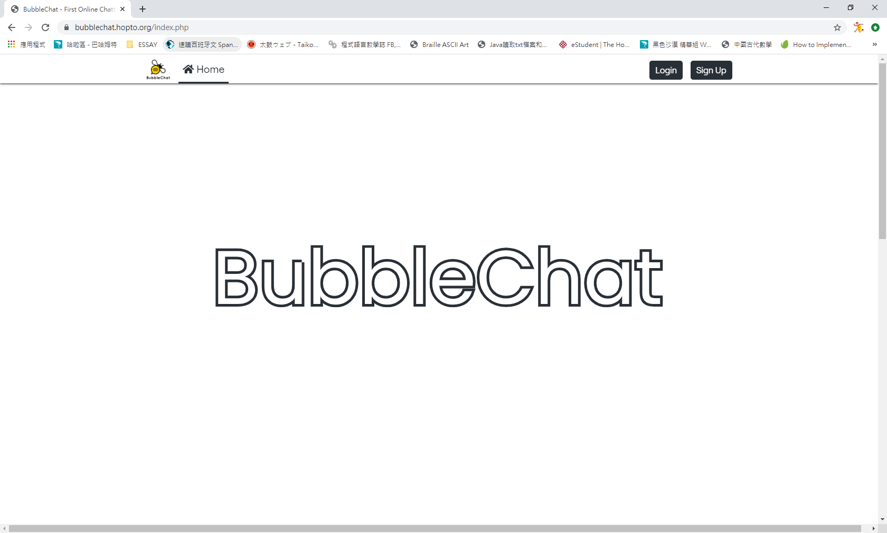

* User Registration

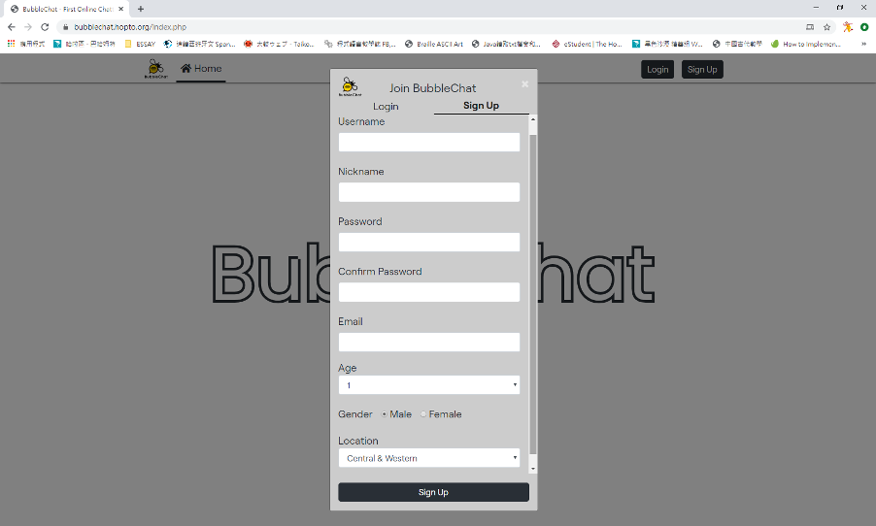

This is the sign-up page for our user, users are required to enter their username, nickname, password, confirmed password, Email and so on to register an account.

To avoid the invalid information inputted by user, we set both client side and server-side validation.

Client-side validation: Email Format and check if any empty blanks.



Server side: same user or same email are not allowed. User collision will be detected.



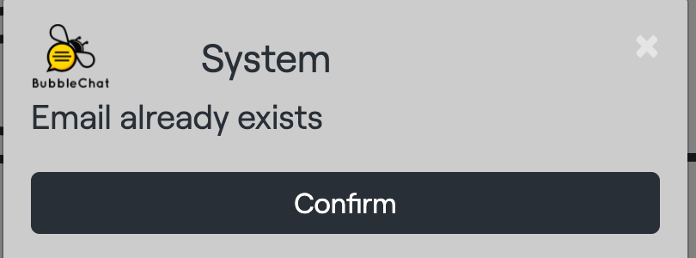

This is the Email Activation. As far as the users have signed up their account, they need to activate their account via their email address for identification. It is useful to block the fake account which created by bots.



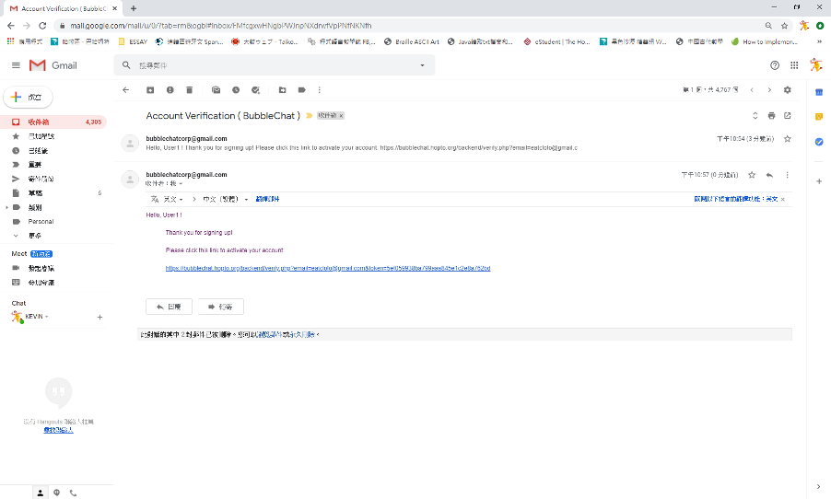

* User Login

This page is used for user to login, they are required to enter their username and password. There is also a forget password button. Once the user forgets his password, he can click it and reset his password through their signed email.

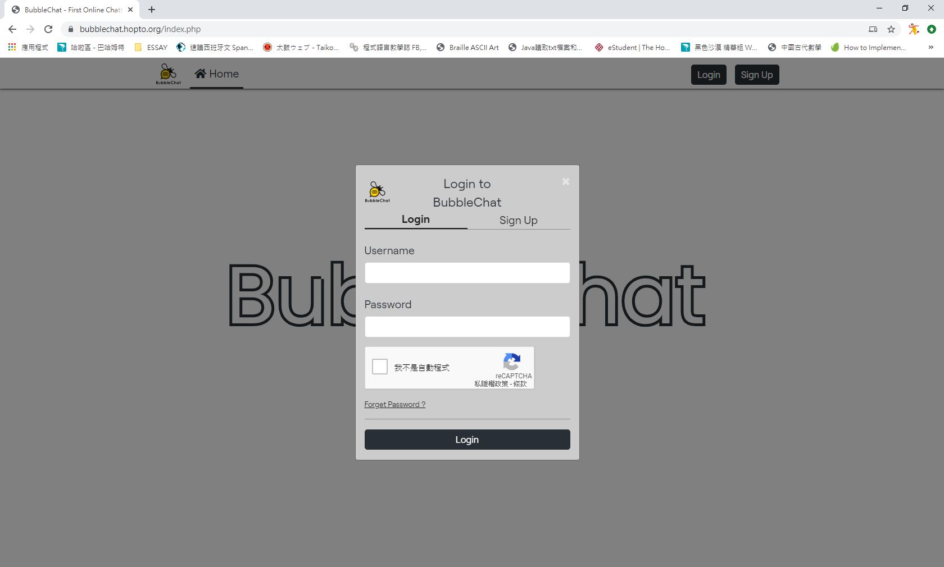

This is the situation when a user inputs the wrong username or password. A generic error message is sent back such as “Entered invalid credentials” so hackers can’t trace the error to the username or password specifically.



This happens when the user enters nothing in the username and password. As well as the client-side validation, it will check if the user has left any empty blank and remind the user.



This happens when the user enters nothing in the username and password. As well as the client-side validation, it will check if the user has left any empty blank and remind the user.

This happens when user login to its account which not activated with their email.

* Cookies

The pop out screen is to show that the website login status is using cookies. User is remained in his account until he presses the logout button.



There is a logout button for users to logout. It used to delete cookie and user login information.

Once if the user forgets his password, he can click the “forget password” button. The schedule is shown below:

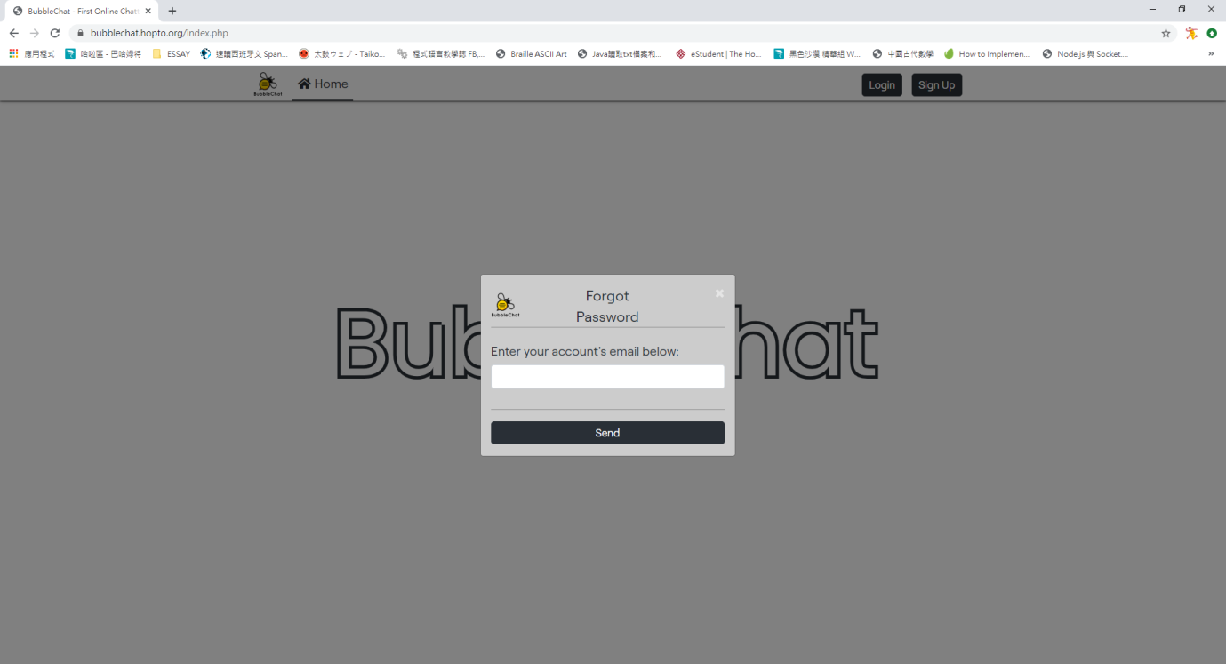

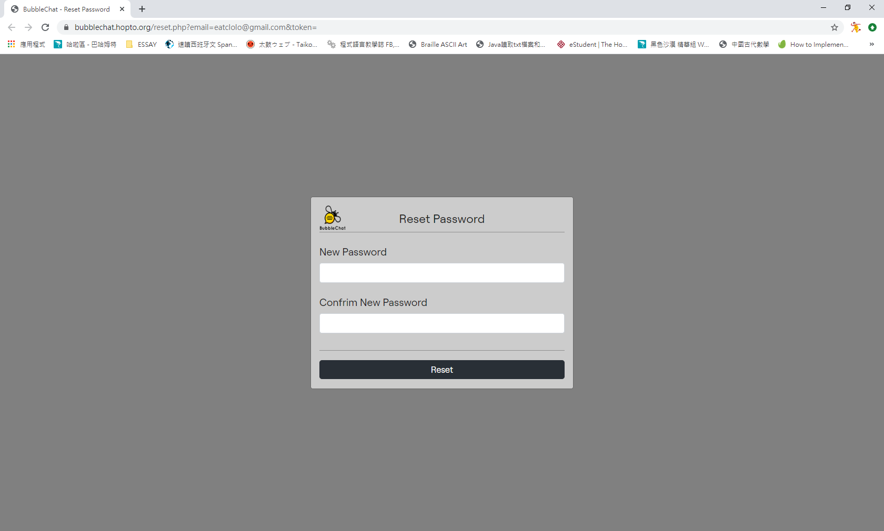

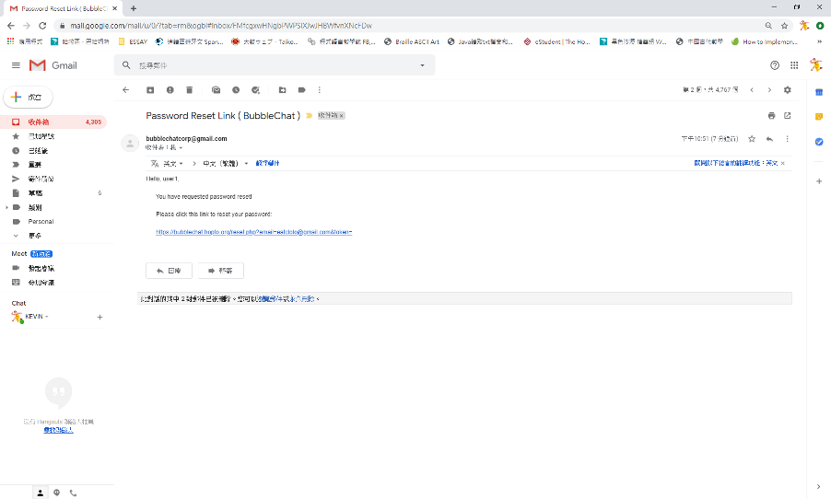

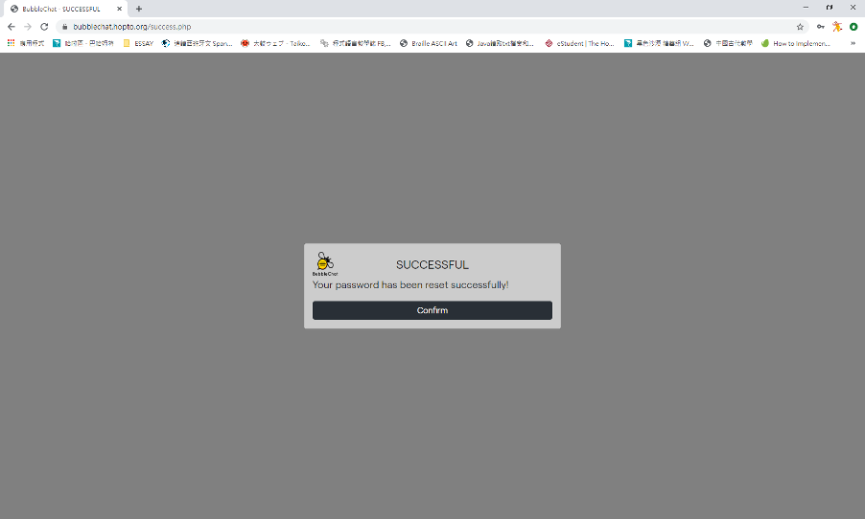

* Profile

After login successfully, user can view his profile and user information.

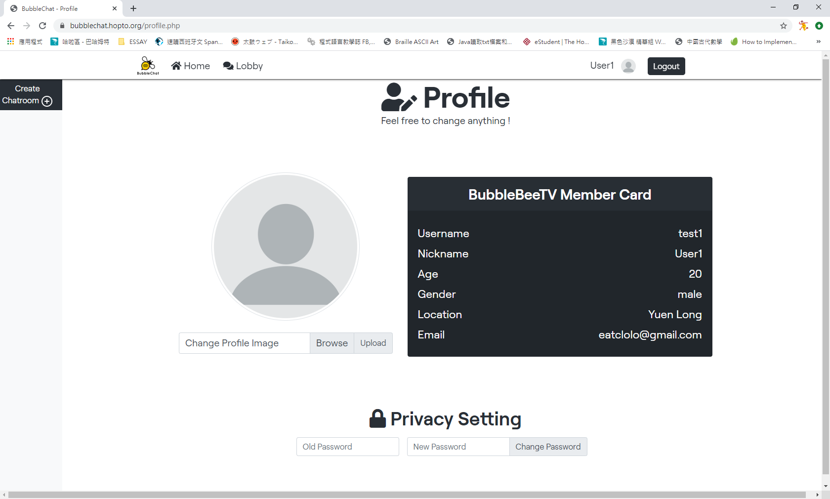

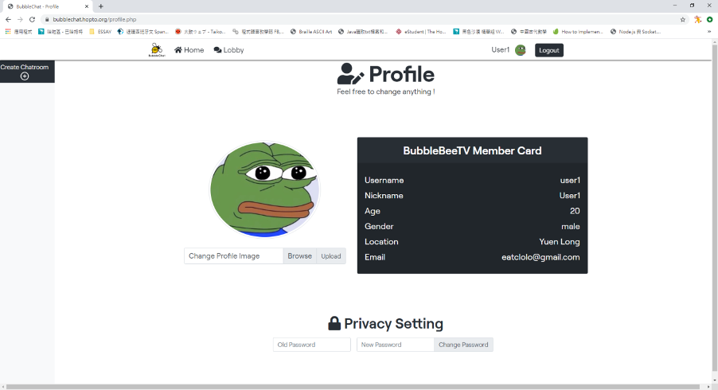

User can change their icon after login successfully.

* User enter Chat Room

This is the lobby. User can choose which chat room to enter.

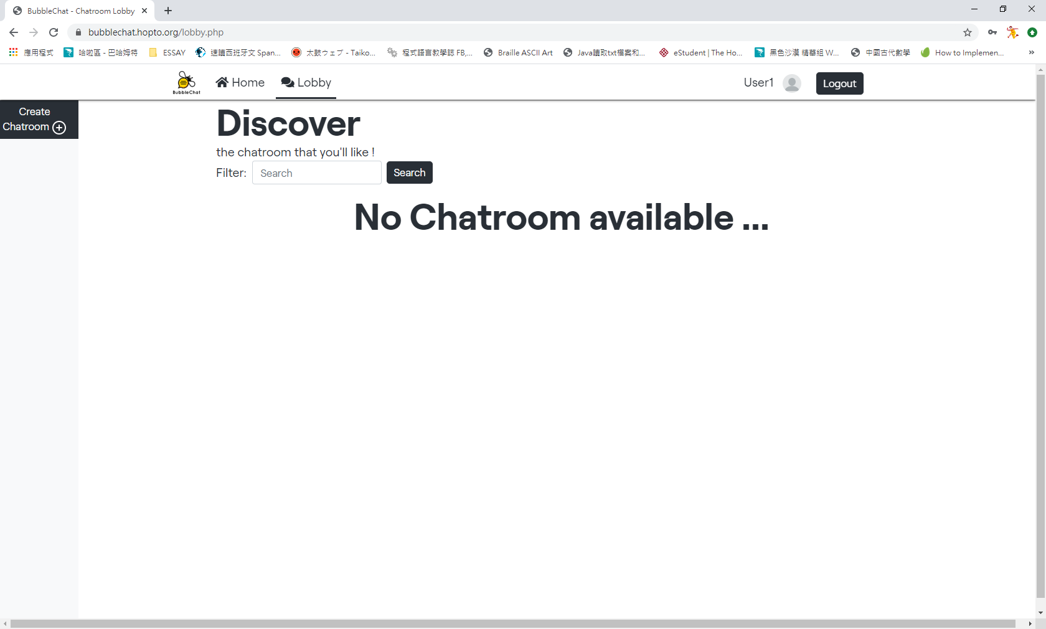

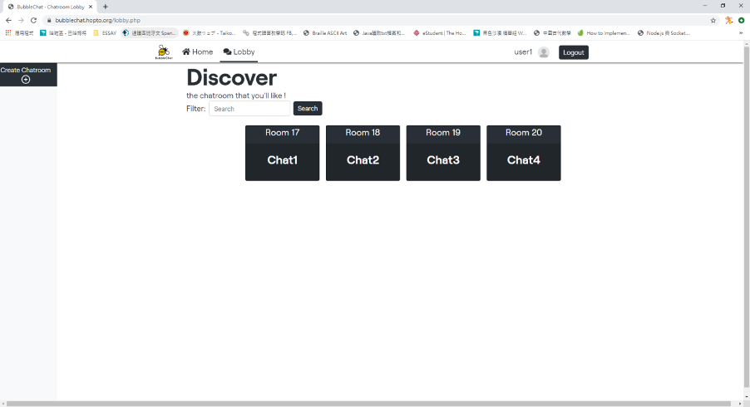

There are a lot of chatrooms in the lobby. We can see that there are different rooms with different categories. Users can choose any room to enter by clicking the room card and it will return them a hyperlink with the corresponding chatroom ID by the GET Method. As a result, the users will redirect to the chatroom webpage.

* Chatroom

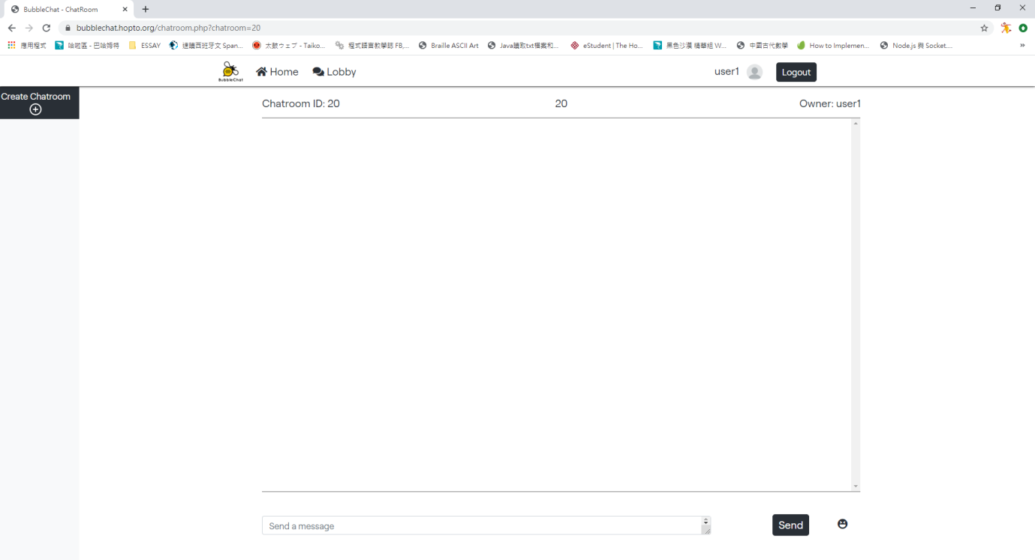

Here is the chat room. It was used for the user to send messages.

* SSL Registration





* SSL Security Check

**